

**ASSIGNMENT GUIDELINES**

* Make the changes in the PPT as you solve the parts
* This file contains the template for all the parts of the project.
* Check the instructions added in the note section of every slide for clarity.
* Don’t move around any image or text box
* If you require more/lesser elements, be careful when you copy/delete the existing ones.

ASSIGNMENT

Name: Denzil Christy

Problem Statement

The sales pipeline conversion percentage at TechnoServe (a tech SaaS startup) has dropped from 35% at the end of last fiscal (FY 2019-20) to 25% at present.

Assignment Objective

Understand the problem, come up with a hypothesis for low conversions faced by TechnoServe, and analyse the dataset provided to arrive at possible solutions to increase it.

**Who?**

A tech SaaS startup, TechnoServe

**What?**

Low pipeline conversion rate.It has dropped from 35% to 25%.

**When?**

From the first quarter of the fiscal year 2019- 20

**Where?**

Problem among the customer.

**How?**

The product does not meet the market demand.

The sales team is inefficient.

**Situation**

1. What are the product offered by the company?
2. How many clients does TechnoServe ha
3. What is the strength of th employees within the company?
4. What is the strength of Sales team at TechnoServe?

**Problem**

1. Are the certain product line which are poor and does not meet the market demand?
2. Are the sales team not skillful to sell the the product?
3. Are there certain leads that are ineffective?

**Implication**

1. How does this low conversion rate affect the companies?
2. Does it affect the future growth of the company?

**Need-Payoff**

1. Does the company will gain more profit and growth if the problem is solved?
2. Will it help the product to redesigned and meet the market demand?
3. Will the companies market share increase?

## Framework Used

Issue tree Framework with 5 C’s Framework

## Reason for using the selected framework

It is easy to cover all the domains using the above mentioned frameworks.

## How you have used the framework here

The problem has been divided into the five C’s in the framework and then, each C is again branched using the issue tree framework

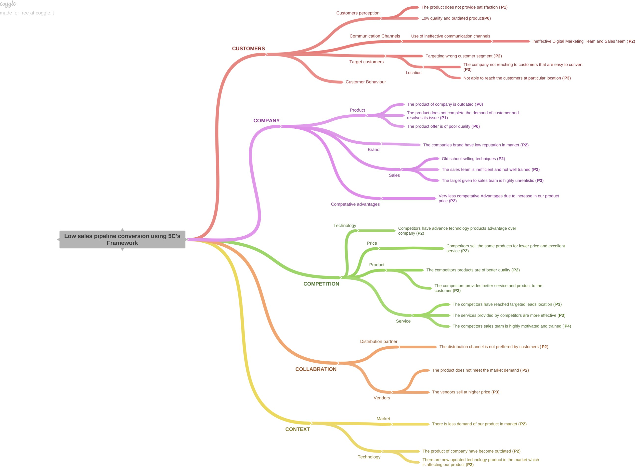

**Branch 1 -- :LOW SALES PIPELINE CONVERSION--CUSTOMER--CUSTOMER PERCEPTION**

1. Low quality and outdated product (P0)
2. The product does not provide satisfaction (P1)

**Branch 2--LOW SALES PIPELINE CONVERSION--CUSTOMER--COMMUNICATION CHANNELS --USE OF INEFFECTIVE COMMUNICATION**

1. Ineffective Digital Marketing Team and Sales team (P2)

**Branch 3** --**LOW SALES PIPELINE CONVERSION-- CUSTOMERS -- TARGET CUSTOMERS**

1. Ineffective Digital Marketing Team and Sales team (P2)

**Branch 4** -- **LOW SALES PIPELINE CONVERSION--CUSTOMERS -- TARGET CUSTOMERS -- LOCATION**

1. The company not reaching to customers that are easy to convert (P3)
2. Not able to reach the customers at particular location (P3)

**Branch 5** --**LOW SALES PIPELINE CONVERSION--CUSTOMER--CUSTOMER BEHAVIOUR**

1. The customer does not buy the product again once buyed (**P2**)

**Branch 6-LOW SALES PIPELINE CONVERSION--COMPANY--PRODUCT**

1. The product of company is outdated (**P0**)
2. The product does not complete the demand of customer and resolves its issue (**P1**)
3. The product offer is of poor quality (**P0**)

**Branch 7** -- **-LOW SALES PIPELINE CONVERSION--COMPANY--BRAND**

1. The companies brand have low reputation in market (**P2**\*\*)**

**Branch 8-- -LOW SALES PIPELINE CONVERSION--COMPANY--BRAND**

1. Old school selling techniques (**P2**)
2. The sales team is inefficient and not well trained (**P2**)
3. The target given to sales team is highly unrealistic (**P3**)

**Branch 9---LOW SALES PIPELINE CONVERSION--COMPANY--COMPETATIVE ADVANTAGE**

1. Very less competative Advantages due to increase in our product price (**P2**)

**Branch 10---LOW SALES PIPELINE CONVERSION--COMPETITION--TECHNOLOGY**

1. Competitors have advance technology products advantage over company (**P2**)

**Branch 11--LOW SALES PIPELINE CONVERSION--COMPETITION--PRICE**

1. Competitors sell the same products for lower price and excellent service (**P2**)

**Branch 12--LOW SALES PIPELINE CONVERSION--COMPETITION--PRODUCT**

1. The competitors products are of better quality (**P2**)
2. The competitors provides better service and product to the customer (**P2**)

**Branch 13--LOW SALES PIPELINE CONVERSION--COMPETITION--SERVICE**

1. The services provided by competitors are more effective (**P3**)
2. The competitors have reached targeted leads location (**P3**)
3. The competitors sales team is highly motivated and trained (**P4**)

**Branch 14--LOW SALES PIPELINE CONVERSION--COLLABRATION--DISTRIBUTION PARTNERS**

1. The distribution channel is not preffered by customers (**P2**)

**Branch 15--LOW SALES PIPELINE CONVERSION--COLLABRATION--VENDORS**

1. The product does not meet the market demand (**P2**)
2. The vendors sell at higher price (**P3**)

**Branch 16---LOW SALES PIPELINE CONVERSION--CONTEXT--MARKET**

1. There is less demand of our product in market (**P2**)

**Branch 17---LOW SALES PIPELINE CONVERSION--CONTEXT--TECNOLOGY**

1. There are new updated technology product in the market which is affecting our product (**P2**)
2. The product of company have become outdated (**P2**)

**Branch 18--LOW SALES PIPELINE CONVERSION--CONTEXT--REGULATION**

1. The new government policies have lead to increase in price of products (**P2**)

**Variable**

Technology Primary B2B sales

Business from clients last year

Client revenue sizing Opportunity sizing

**Insights if any**

ERP Implementation have better conversion rate than the other category

Enterprise and Marketing seller have more opportunities and among this Enterprise seller have more conversion rate as compared to others .

The conversion rate is high for existing but more opportunities are for coming from new customers.

Suprisingly there are more opportunity coming from cliens who less revenue resizing

The opportunity comversion rate is significantly higher for those client who have less than 100k revenue size .The conversion rate is higher for the clients who have revenue sizee of 10k and less.

**Pattern of Insight**

Significant Outliers Significant Outliers

Significant Outliers Significant Outliers Significant Outliers

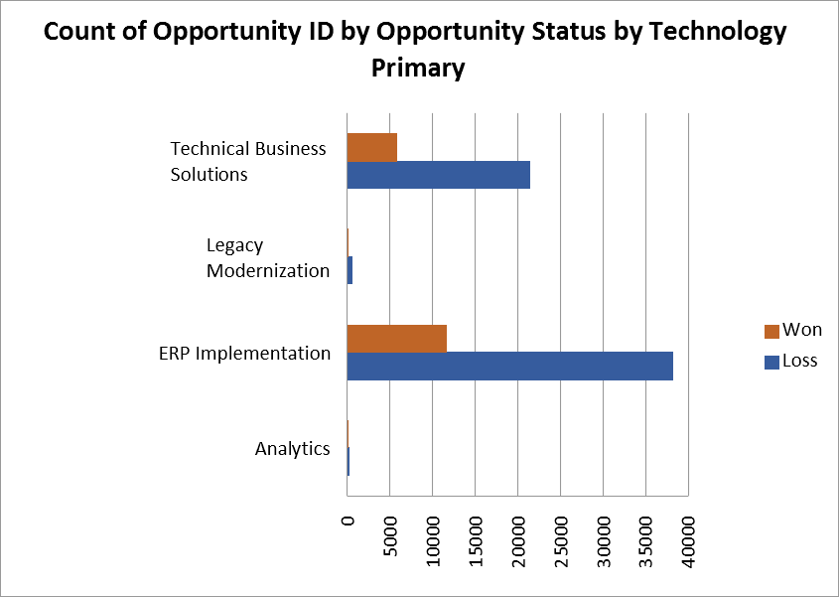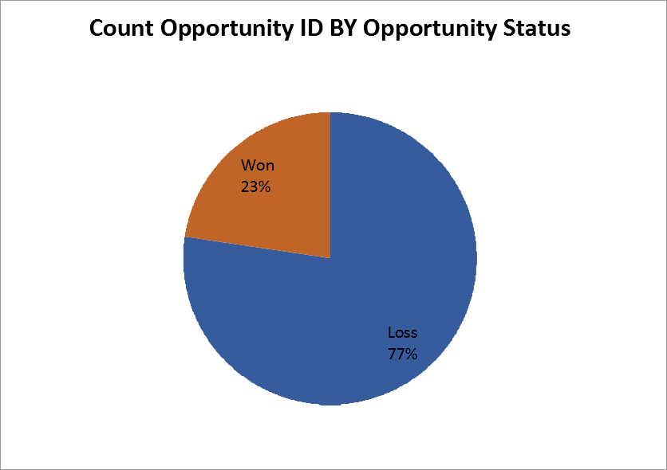

## Variable under consideration: Technology Primary

ERP Implementation have better conversion rate thaan the other category

# Sales Pipeline Conversion at a SaaS Startups

**Variable under consideration: B2B Sales**

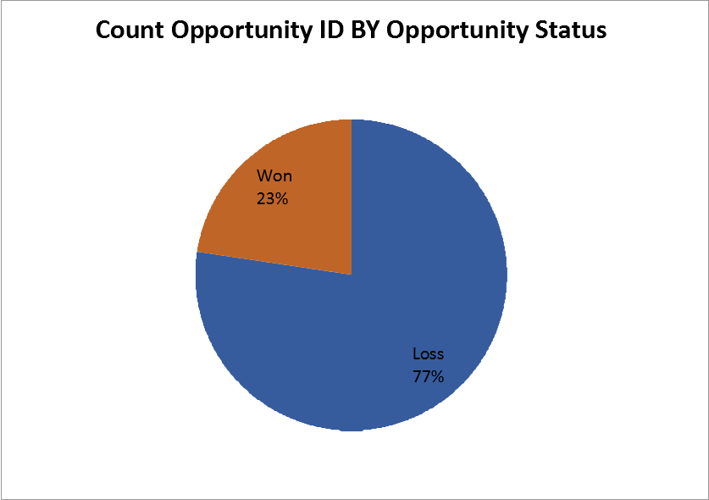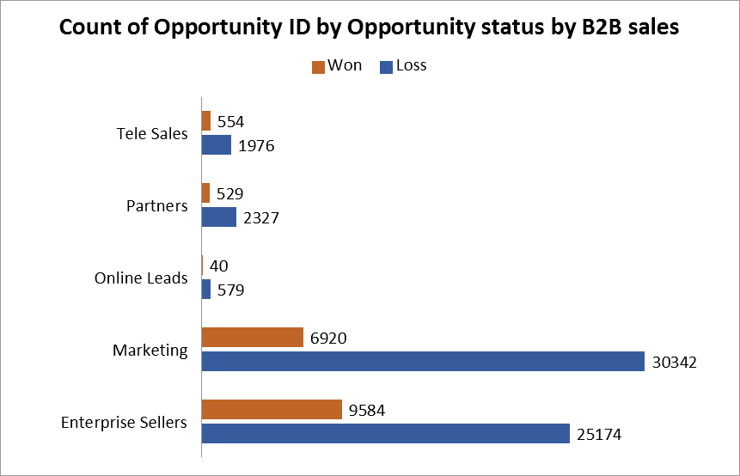

**Enterprise and Marketing seller have more opportunities and among this Enterprise seller have more conversion rate as compared to others .**

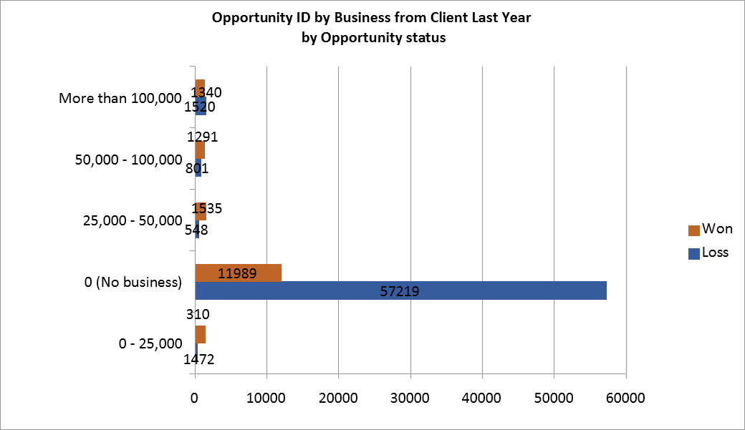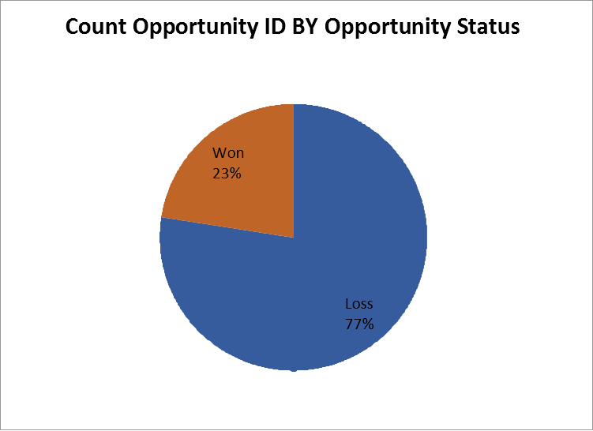

**Variable under consideration:**

The conversion rate is higher for new customer

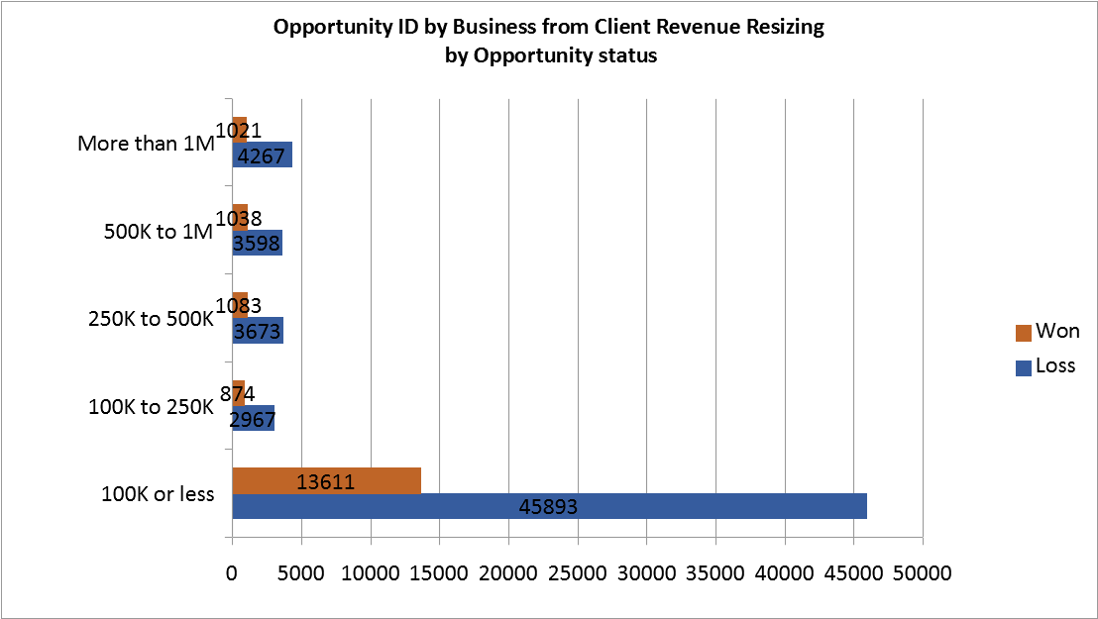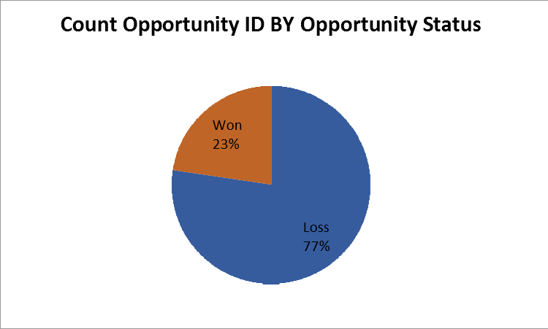

**Variable under consideration:**Client revenue sizing

Suprisingly there are more opportunity coming from cliens who less revenue resizing (100k and less)

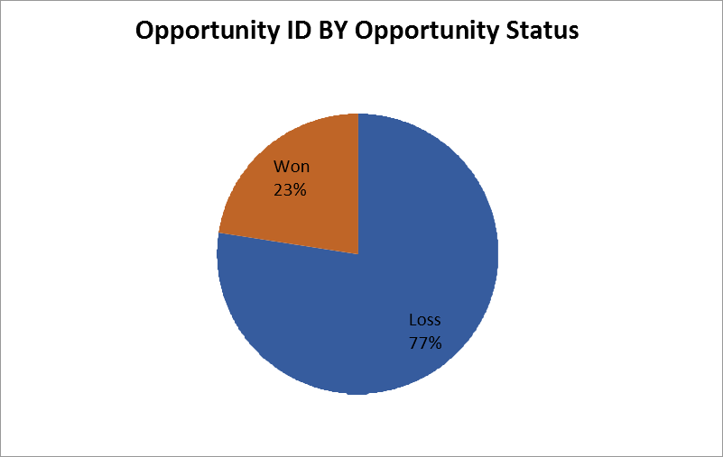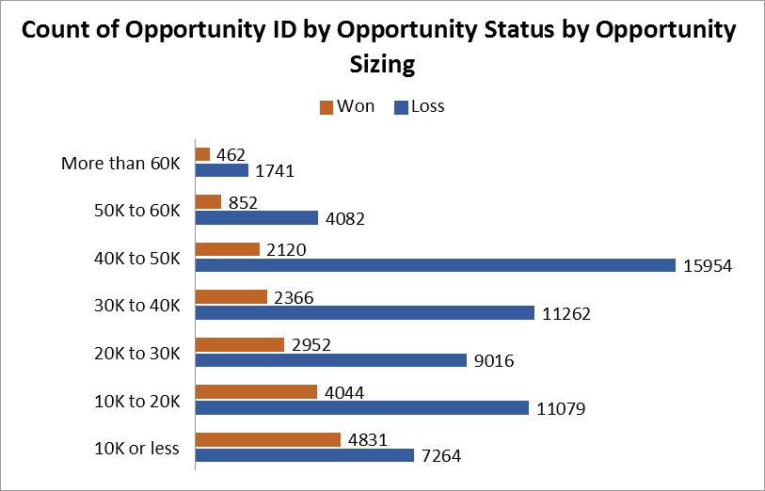

## Variable under consideration: Opportunity Sizing

The opportunity comversion rate is significantly higher for those client who have less than 100k revenue size .The conversion rate is higher for the clients who have revenue size of 0 to 30k and less.

## Corresponding Insights

**Recommendations**

Company should focus on following points in order to have high conversion rate.

ERP implementation solutions Enterprise Seller as B2B sales medium

Existing Customers

Less revenue size customers (100k or less)

Opportunity sizing (0-30k)

ERP Implementation have better conversion rate than the other category

Enterprise and Marketing seller have more opportunities and among this Enterprise seller have more conversion rate as compared to others .

The conversion rate is high for existing but more opportunities are for coming from new customers.

Suprisingly there are more opportunity coming from clients who less revenue resizing (100k or less)

The opportunity comversion rate is significantly higher for those client who have less than 100k revenue size .The conversion rate is higher for the clients who have revenue size of 0 to 30k and less.

**FINAL RECOMMENDATIONS**

ERP implementation solutions Enterprise Seller as B2B sales medium

Existing Customers

Less revenue size customers (100k or less)

Opportunity sizing (0-30k)

## Focus on ERP implementation category solutions

ERP Implementation have better conversion rate than the other category

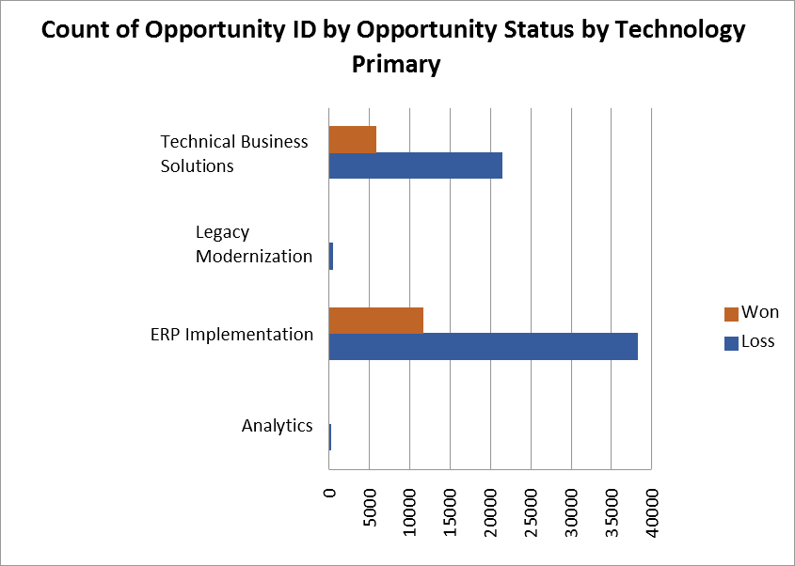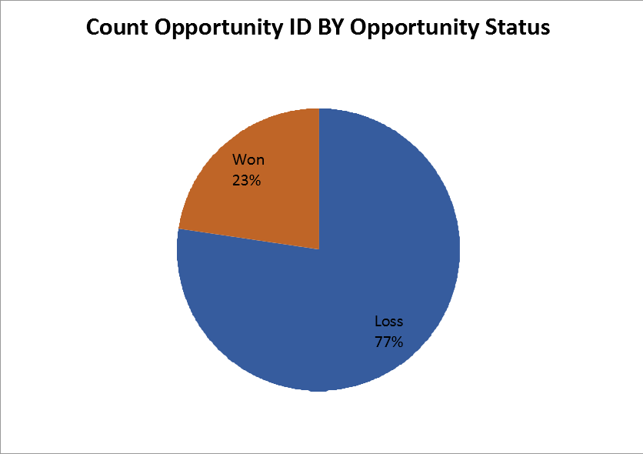

## Focus on Enterprise Seller as B2B sales medium

Enterprise and Marketing seller have more opportunities and among this Enterprise seller have more conversion rate as compared to others .

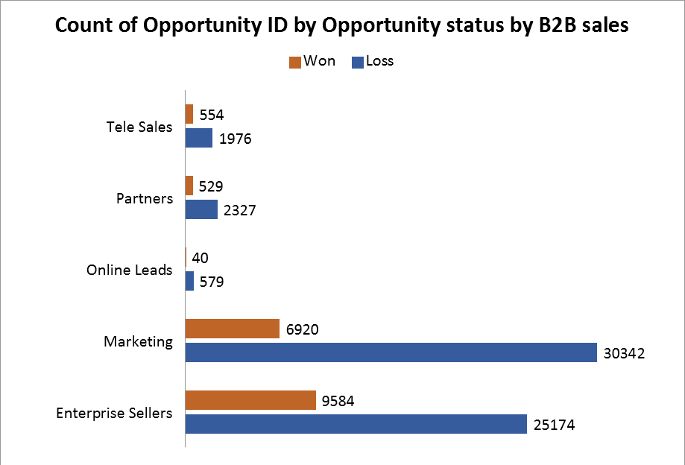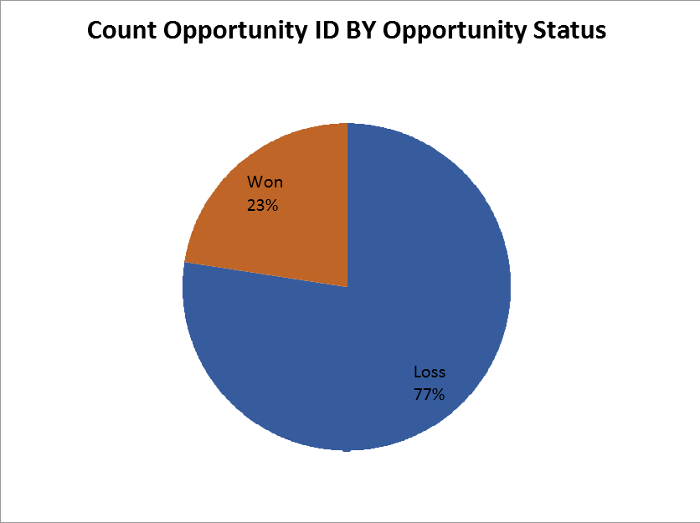

## Focus on Existing Customers

The conversion rate is high for existing but more opportunities are for coming from new customers.

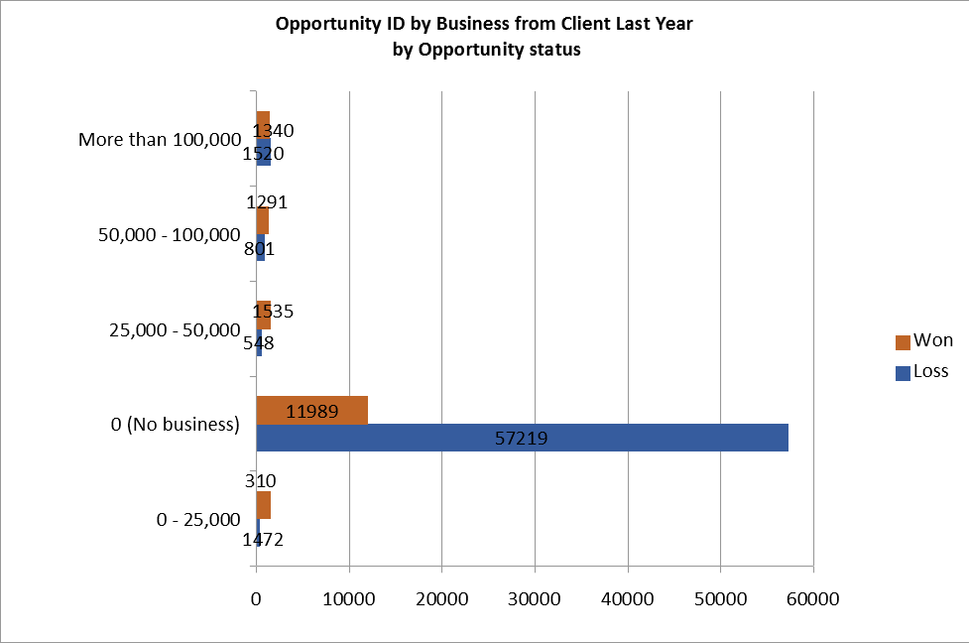

## Focus on Less revenue size customers (100k or less)

Suprisingly there are more opportunity coming from clients who less revenue resizing (100k or less)

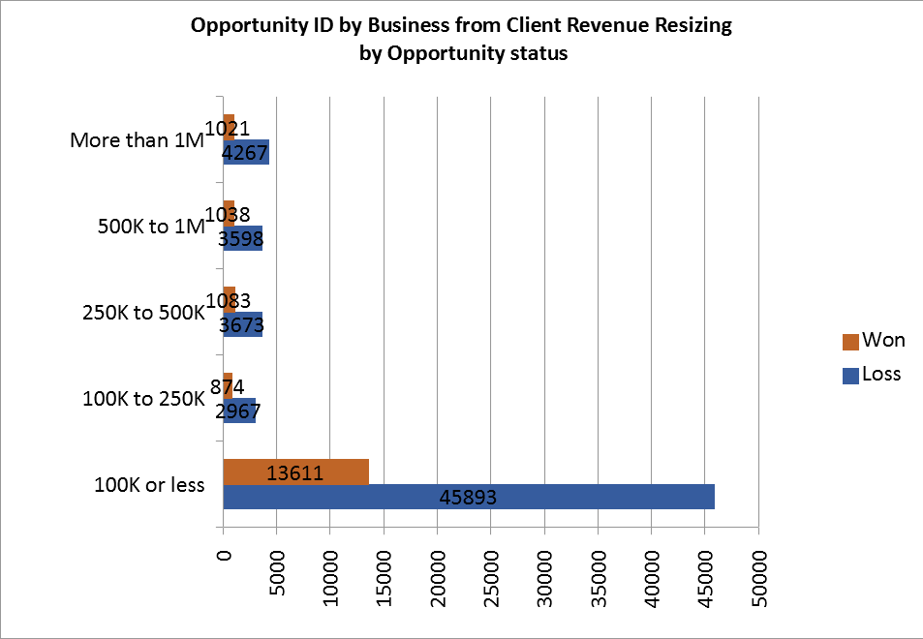

## Focus on Opportunity sizing (0-30k)

The opportunity comversion rate is significantly higher for those client who have less than 100k revenue size .The conversion rate is higher for the clients who have revenue size of 0 to 30k and less.

